MLOps Project - Vehicle Insurance Data Pipeline

Welcome to this MLOps project, designed to demonstrate a robust pipeline for managing vehicle insurance data. This project aims to impress recruiters and visitors by showcasing the various tools, techniques, services, and features that go into building and deploying a machine learning pipeline for real-world data management. Follow along to learn about project setup, data processing, model deployment, and CI/CD automation!

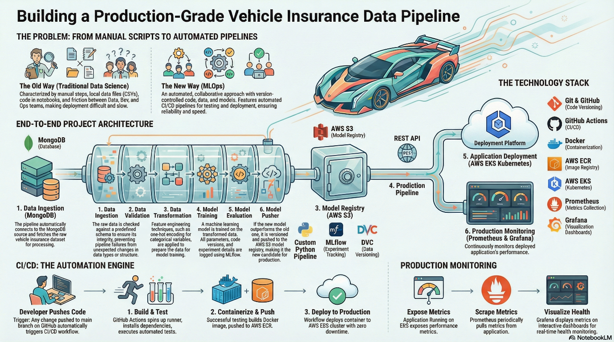

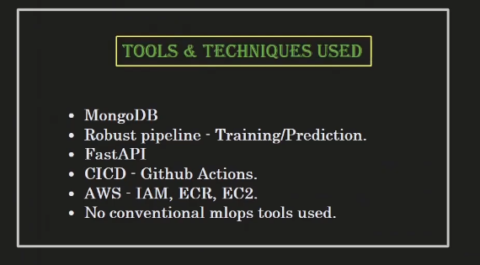
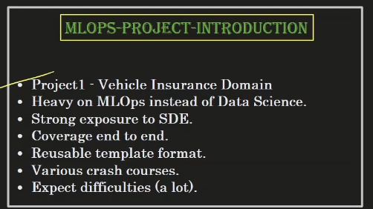

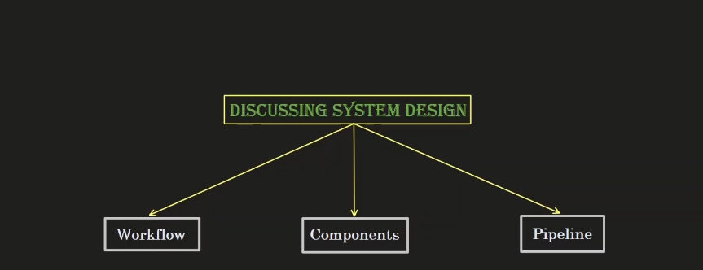

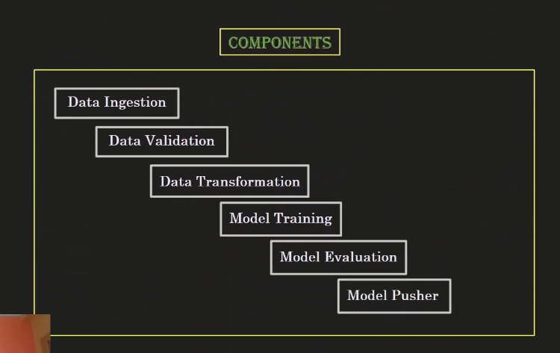

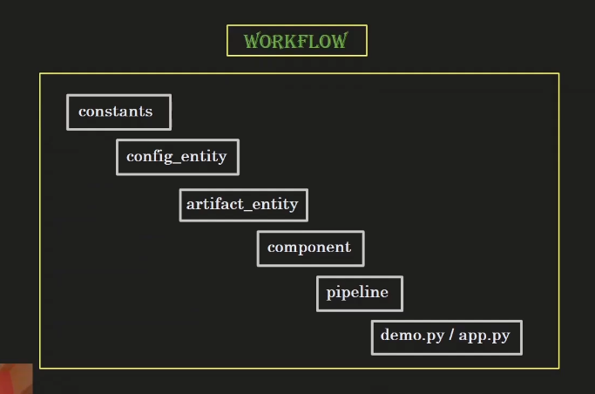
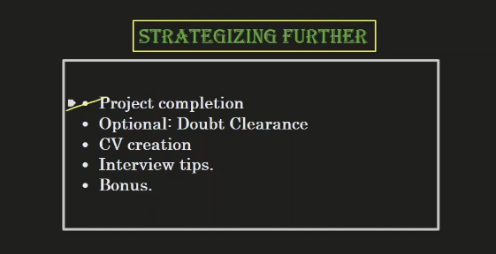

Database user!

shalinvachheta2016_db_user

P7No1BSXa364FE1P

Connection method:
python -m pip install "pymongo[srv]==3.12"
mongodb+srv://shalinvachheta2016_db_user:<db_password>@cluster0.zsumpop.mongodb.net/?appName=Cluster0
mongodb+srv://shalinvachheta2016_db_user:<P7No1BSXa364FE1P>@cluster0.zsumpop.mongodb.net/?appName=Cluster0

